Collapsing Boundaries

Lucy Bartholomee
AEAH 5801.00 1American Architecture, Design, and Urbanism: Denton Palimpsest
University of North Texas
December 9, 2014

One ever feels his two-ness—an American, a Negro; two souls, two thoughts, two unreconciled strivings; two warring ideals on one dark body, whose dogged strength alone keeps it from being torn asunder.”
-W.E.B. DuBois

Utilizing the home of an African-American medical doctor as a focal point, this paper strives to contribute to the dialogue surrounding the Quakertown history using the phenomenological lens of racially categorized bodies occupying a racially neutral house. With support from authorities in racial identity such as Grace Elizabeth Hale, Sara Ahmed, and Franz Fanon, I will examine the perceived threat to the Southern U.S. cultural identity of Whiteness as a result of the African-American Quakertown residents’ incursion into white cultural practices. Essentially, the success of Dr. Edwin Moten and others from the African American community in acquiring the material objects of white middle class success, such as a well-built home and fine clothing, threatens to upheave social constructs developed by white society in the post-emancipation era. The broad concept of racism is multifaceted and multidirectional, and often sadly inexplicable. This paper seeks to carefully ponder one particular aspect of racism in the southern United States, and in Denton, Texas in particular, which is the formation of white middle class identity through the material culture of possessions such as clothing and houses, and the challenge to this perception of white identity presented by African American residents of Quakertown who had equaled or exceeded such ownership.
In recent decades, historians have uncovered and published the evidence of the Quakertown story, often recounted with compassion and sensitivity, attributing the motivations behind the events to racism and economics. Within the city of Denton, Texas, where the city park is now located, lived a thriving community of African Americans from the mid 1800’s until their forced relocation in 1922.
The founding settlers of Quakertown were emancipated by a group of devout Quakers, thus the name of their community honors their benefactors. Oral histories collected by Letitia DeBurgos tell us that “Quakertown was a town within a town by the early 1870’s.” At this time, Denton, Texas was a primarily white community with a few pockets of African American residents. Quakertown grew and prospered over the following decades. By 1920, it encompassed a region approximately five blocks north to south and four blocks east to west in the midst of the town of Denton, Texas (see map, Figure 12). Two streams wove through the neighborhood, where trees were plentiful and the rich topsoil encouraged small family gardens. Quakertown also benefited from “its proximity to the city square, plus the opportunity for African Americans to purchase land, own businesses, and for their children to attend the Quakertown school.” Three churches were built and no fewer than five civic organizations and lodges were established. A variety of businesses were founded by the residents of Quakertown, and whose citizens also worked throughout Denton.
This thriving prosperity was not to last, however. Before 1920, there were forces within the city maneuvering to compel the residents of Quakertown to relocate. The president of the “Girl’s College of Industrial Arts” F.M. Bralley spearheaded the campaign to remove the whole community from Denton. He and civic leaders actively campaigned within the white civic leadership to clear the area. Bralley’s school was openly a school for white girls, and the presence of a rather large African American community between the growing school and the town square and railroad station, caused a publicity problem for the school. Pressure mounted as the Ku Klux Klan made many appearances to stoke the fires of the growing tension. In 1922, the city of Denton voted to purchase the land owned by the residents of Quakertown for the purposes of a building a city park, and despite some efforts to resist the African American community was forcibly scattered and relocated.
The story of Quakertown has many more incidents and details, and this brief summary does not do justice to the lives of the individuals and families who were disheartened and mistreated through these tragic events. The goal of this writing is to focus on a particular facet of the case: the cultural identity of the white community as threatened by the presence of the black community within the borders of their town, and specifically to examine the perception of Whiteness among white Southerners through material objects as they sought to establish a culture of difference between themselves and the African Americans living among them.
In the emerging post-emancipation society, as the Jim Crow era was evolving, the interactions and separations between races generated endless tension. No longer slaves, African-Americans sought to establish themselves as independent citizens through industrial and professional jobs, owning businesses, building homes and establishing families that could live in close proximity and remain intact. Grace Elizabeth Hale’s observations are significant in this examination:
The overlapping of the aftermath of the Civil War and the fate of the ex-slaves with these economic changes destabilized the categories of power during the 1880’s and 1890’s. The question of what structure of social ordering would replace the familiar hierarchies of both North and South made this a period of volatility and uncertainty. Hierarchical structures founded in the personalized social relations of specific localities lost their authority in an increasingly mobile and rapidly changing society. How would people know who they were within this spinning abstraction, the newly economically integrated, industrialized nation-state?

The white community anxiously found itself with a need to construct identity. Without the distinction of ‘owned’ and ‘free,’ they turned to skin color, polarized through language into the binary of black and white. This identity crisis manifested in many ways, including the ownership of material objects as cultural identity, challenged by racially bodied identity.
In the community of Denton, Texas at the turn of the century, the need to separate and control property was an outward expression of the desperate need to establish and affirm the identity of the white community. The academic concept of material culture strives to examine the intersection between humanity and the objects it creates and utilizes, where “materiality is an integral dimension of culture.” Objects of material culture are of course extremely numerous. In Quakertown, the photographic record offers homes and clothing as a means to directly compare the lives of white and black citizens. The tension arises when the contrast breaks down. A few African Americans in Quakertown, such as Dr. Edwin Moten, acquired homes and clothing very similar to objects belonging to the white middle class. This similarity must have added to the stress and distress of white Dentonites struggling to form racial identity. As W.E.B. Du Bois phrased it in 1905 with essential eloquence: “How does it feel to be a problem? I answer seldom a word.”
Author Franz Fanon, born in Martinique and working through the mid-century, observes, anguishes, and battles against the perceptions the white world has against his black body: “With me, things take on a new face. I’m not given a second chance. I am overdetermined from the outside. I am a slave not to the “idea” others have of me, but to my appearance.” This surface appearance is the first and only thing many Whites see when looking at a Black person, perhaps especially during the first generations after the civil war and emancipation. Fanon articulates the reverberations of DuBois’ anguish: “I arrive slowly in the world…the white gaze, the only valid one, is already dissecting me. I am fixed”
The African American community of Quakertown was surrounded by this ‘white gaze.’ On a few square blocks of wooded land, where two streams ran through providing fresh water, more than sixty families built their homes. Most residents of Quakertown owned their homes, sometimes financing through banks and hiring white contractors to build new buildings for them. The contractors they hired were the same builders that the white families used. Naturally, many of the houses these contractors built looked quite similar across many neighborhoods. A few residents developed their entrepreneurship by owning several properties, renting homes to each other and also sometimes white families, such as the home that is now the structure housing the African American Museum of Denton. Some residents of Quakertown worked in the homes of the wealthy white Dentonites, at the growing Texas Women’s University (then the College of Industrial Arts), and at a variety of businesses around town. I mention all of these perhaps obvious details for this reason: there was constant interaction between blacks and whites in Denton. The intersection of their lives was continual, and was even enhanced by the logistical reality of the Quakertown community clustered in the center of Denton’s economic district between the courthouse, downtown businesses, and the growing College of Industrial Arts.
As the boundaries between the communities began to disintegrate, the threat of integration loomed ever closer. What happens to the town-within-a-town when the larger, surrounding community, decides to eject the inner town? There is clear evidence that leadership from the CIA and the KKK practitioners considered Quakertown a cancer to be removed swiftly and surgically, through intimidation as well as legal maneuvers. The separation of the communities through the boundaries of streets and neighborhoods was porous, not a restrictive boundary efficiently keeping the communities fully separate. Not only did a few white families live inside Quakertown, it was situated between the College of Industrial Arts and the downtown business district, including the railroad station. Students and faculty had to pass through or around Quakertown on a regular basis, and visiting families would not be able to ignore the presence of the African-American community adjacent to the school where their White daughters would potentially live. The racialization of their bodies by the white community ‘fixed’ their identity with no regard for the law-abiding citizens who actually lived there.
The interaction was not only among their bodies, but with their property as well. As Sarah Ahmed explains: “Cultures come to be lived as having a certain shape, or skin, as an effect of such contact…the story of cultural contact also involves the reproduction of culture.” The homes and churches, carts and carriages, toys and treasures of Quakertown were in constant contact with similar objects utilized by white Dentonites.
“The contact between objects puts more than objects near, insofar as objects reside or dwell within cultures as embodiments of their history, and even take the shape of this dwelling. Such contact may be asymmetrical and yet it affects both “sides,” creating cultural forms that are not simply one or the other.”

Ahmed proposes that the interaction of cultural objects affect and inform both “sides” of a cultural divide, giving form and definition to each identity even as it changes those very definitions. “Theirs” and “ours” are both identified and challenged by proximity, particularly when the objects are in fact identical.
The fact that some Quakertown houses were occupied by whites, and that ‘white streets’ bordered the community, suggest that the seeds were already planted for an interracial community in the growing city of Denton. Dr. Moten’s home at 702 Bell Avenue was poised to cultivate this inter-raciality. In examining the photo of Figure 1, we see a home that is nicely maintained, large enough for a family, and with at least one room upstairs. The paint is fresh, all windows and doors are in perfect repair, and an inviting porch swing awaits. A wide hedge is suggested at the edge of his property. The lot directly behind the Moten home on Vine Street remained empty while he lived there, although the adjacent property further North on Vine Street was developed with single family houses. Still, his White neighbors on the next street over would have felt the presence their other Black neighbors adjacent to their property line.
Dr. Moten positioned his family on the border of Quakertown (see Quakertown map, Figure 12). Although the properties to the north of 702 Bell Street were occupied by Quakertown residents, the property to the south also remained empty while he lived there. He was truly on the edge of the Quakertown neighborhood, physically and metaphorically.
Built in the Folk Victorian style, Dr. Moten’s home had the typical front-gabled roof with a front wing. The influence of Colonial Revival style is apparent in the small white columns that elegantly accent and support the structure. A covered front porch the same height as the first floor is found in both Folk Victorian and Colonial Revival styles. Long windows allowed in fresh breezes during the warm months of the year, a necessity in Texas before the invention of air conditioning. The combined styles are evident again in the Pyramidal roof that emerges above the front porch, centered to provide a focal point as well as light and air into the upstairs rooms. Another influence is the Queen Anne style, evident in the decorative spindle work on the windows, as well as the multiple roof pitch.
It is important to note that many other African Americans at this time period in the United States lived in significantly worse conditions than those found in Quakertown. Historical photos consistently depict homes that were well-constructed, if humble. There are no piles of garbage or wandering livestock in the images. While a posed picture would not be expected to include such negative details, there are many un-staged pictures as well. The founders of this community likely left behind plantation and farmhouses houses such as the overcrowded homes described by W.E.B. DuBois in The Souls of Black Folk, first published in 1903:
Light and ventilation are supplied by the singe door and by the square hole in the wall with its wooden shutter. There is no glass, porch or ornamentation without. Within is a fireplace, black and smoky, and usually unsteady with age. A bed or two, a table, a wooden chest, and a few chairs compose the furniture; while a stray show-bill or a newspaper makes up the decorations for the walls. Now and then one may find a cabin kept scrupulously neat, with merry steaming fire-place and hospitable door; but the majority are dirty and dilapidated, smelling of eating and sleeping, poorly ventilated, and anything but homes.

Such living conditions would reinforce the developing identity of Whiteness held by the landlords of these properties, whether they were located by the old plantations of the South or adjacent to Northern factories. As Ahmed observes: “Not only is the whiteness of the white body endangered by some of the proximities it inherits, but some forms of proximity with bodies that are marked by difference are permitted: proximity to such others can even “confirm” the whiteness of the body.”
The founders of Quakertown had enough hope and ambition to seek an empty tract of land, build houses, establish businesses, and simply live. For the White residents of Denton, the identity of ‘self’ was established by the identity of ‘other,’ through skin color first and possessions, objects of material culture, second. As he boundaries between ‘theirs’ and ‘ours’ decreased, social tension rapidly increased.
Let us return now to 702 Bell Avenue, Figure 1, and compare it to Figures 2, 3, and 4, all houses to the Southwest of Quakertown by only a few short blocks, and all belonging to white families. These houses were selected for examination by the architectural similarity to Dr. Moten’s home. Pyramidal roof and one-story covered front porches are found on all of these, with some variations. The front facing of the home in Figure 4 is essentially a reversal of Dr. Moten’s home. The houses in Figures 3 and 4 are somewhat smaller, although they are all wood frame houses with influences from Colonial Revival as Folk Victorian home designs. Figure 2 most directly corresponds to the Quakertown home in both design and size. The Sanborn Map of 1921 (Figure 12) was made just one year before the dispersion of Quakertown. Dr. Moten’s home is clearly much larger than the homes around him; in fact, few buildings of any kind are of equal or greater size on the map. While the Sanborn Map doss not promise a scientifically scaled replication of the buildings, but there is a distance scale, and the careful record suggests a fair indicator of their relative sizes.
The multi-pitched roof system provides an attractive visual variety to the eye in both Dr. Moten’s home and that of Figure 2. Large front porches allow the owners to enjoy fresh air out of doors while in the shade, able to visit with neighbors or watch passersby. Figure 2 has somewhat more Queen Ann stylistic details, such as double columns and lattice on the porch. Otherwise, these houses appear remarkably similar, thus complicating the identity of ownership through racially neutral property and thereby blurring the lines between ‘self’ and ‘other.’
This is why even bodies that “appear” with a white surface, or a surface that has perhaps only a little color, still have to pass [as white] in order to pass into white space: the white body must also be a respectable and clean body. Such a body is also middle class and straight: it is a body that is “in line” with the “lines” that accumulate as signs of history to become institutional givens.

The African American people in Quakertown did not attempt to change their surface appearance, their actual skin. Their acquisition of objects, including homes, clothing and hairstyles, provide an acquired surface that can be equated with white middle class society.
Clothing is an instant signifier of identity and social standing. Consider the apparel of Dr. Moten and his family in Figure 5. They are seated in a formal setting for a family portrait. Although we do not have the photographer’s name, the stiff pose of the family suggest a hired photographer. The background could be a home, but the grainy textures suggest a studio set rather than an authentic living room. Dr, Moten wears a suit with matching jacket and pants and a high starched collar. It is possible that he wears a white tuxedo tie, but the slight overexposure of the image obscures that detail. A white straw hat rests on his right leg. These are the attributes of a well-dressed gentleman. Dr. Moten’s daughters, Myrtle and Carrie, wear white or light colored dresses, spotlessly clean, with ribbons to hold back their carefully styled hair. None of the family’s shoes are visible in this photo, which is cropped across the bottom.
Mrs. Moten’s dress is particularly interesting, especially when compared to the clothing of the Ariel Club from 1904, a white women’s club in Denton (Figure 10). These dresses have many stylistic similarities. All of the ladies in both photos wear dresses with fully covered bodices and a high neck line. Sleeves are puffed at the shoulder and upper arm, and extend to the wrist. Susie Whitlock Moten’s dress has a fitted bodice and waist, as do the ladies of the Ariel Club. Both Mrs. Moten and the white ladies wear long, full-length skirts. There is some variety of material and colors suggested by the black and white photos. The all-white Ariel Club is outdoors and all of the ladies are wearing rather sizable hats with feathers and other embellishments. Mrs. Moten is pictured indoors, without a hat either on her head or in hand. Otherwise, they are dressed in quite a similar manner. The resemblance is noticeable now, and would certainly have been observed in the racially charged era under examination.
The children also play a role in this analysis. Figures 6, 7 and 8 picture the children of Dr. Moten at play or with their parents. The children in Figure 6 ride a clever pedaled carriage wearing dressy, light-colored clean clothes. The pedal car brings into play the idea of motility, a concept that includes but reaches beyond freedom of movement: “We most note here that the extension of motility through objects mans that the object is no longer perceived as something apart from the body.” The pedal car gives the children the physical mobility to ride around their neighborhood and beyond, the privilege of the toy itself gives them motility to expect greater freedom of movement (socially as well as physically) in the future.
The adorable child in Figure 7 is Carrie Annetta Moten. She is luxuriously clad in a velvet dress with a matching hat and leather boots, an expensive outfit for the child of any family in 1910. Author bell hooks [sic] speaks from her own African-American perspective about the meaning of such items: “Objects are not without spirit. As living things they touch us in unimagined ways.” Toys and clothing have a place in material culture that exceeds mere fabrication. Objects given to children often demonstrate love and the value the child has in the home, as well as the abundance of the family’s material wealth.
Finally, let us compare Dr. Moten’s family with that of this white family from 1900 in the Denton County records (Figure 11). Their clothing is far less expensive and of a less stylish design. The children wear clothing that fits them, made of thin cotton prints, although the young boy closest to his father looks as if his clothing is quite uncomfortable and the sleeves are beginning to get too short. The baby’s light colored dress is similar to the dresses of Dr. Moten’s daughters in Figure 5, but the white child has no shoes. Although the feet of the Moten family are cropped out of the picture, the formality of their attire makes it unlikely that anyone came to the photo session barefoot. These two families represent racialized bodies in racially unequal clothing. The undercurrents of racial identity in photos like these can be read to reveal an intense dilemma for whites in the Southern United States during this period, and perhaps echoing through the decades to today.
It is hard to dehumanize the “Other” when you daily see them living as families, caring for their children in their homes, going to school, shopping and going to church. As the white gaze sees the children grow up, it becomes aware of marriages and funerals; the white gaze struggles to avoid black bodies behaving much like their own white bodies. Fanon resists the efforts to ignore his existence, and extends his body into humanity: “With all my being, I refuse to accept…amputation. I feel my soul as vast as the world, truly a soul as deep as the deepest of rivers; my chest has the power to expand to infinity.” The very humanizing activities of life in Quakertown were before the eyes of the white community, their vitality undeniable.
In addition to the struggle with identity, evil was present in the form of violent racism and the KKK. Those in the white community who wanted to build up the boundaries of separation between these two races, who wanted to increase the distance between self and other, were motivated to find socially acceptable reasons to move Quakertown out of the physical sight of the white community. Fanon laments: “A feeling of inferiority? No, a feeling of not existing. Sin is black as virtue is white. All those white men, fingering their guns, can’t be wrong. I am guilty. I don’t know what of, but I know I am a wretch.” Fanon’s guilt is his body, it is simply the wearing of his skin.
Dr. Moten seems to be a man who rejected the ‘wretched amputation’ of the white gaze, carving out a metaphorical as well as physical space for himself and his family at the outer edge of the community. Quakertown needed a black physician and highly respected Dr. Moten and his family. Prosperous and well educated, he was a prominent figure. Yet his residence at 702 Bell Street was on the border, the East side of Bell Street that was not even wanted for the city park development. So the good doctor was adjacent to his clientele, but set apart from them. When tensions and hostilities mounted in 1922, he moved his family north to Indianapolis.
Freedom of motility, the “promise of social mobility” as well as freedom of physical movement was seized by Dr. Moten and only a few others in Quakertown. One manifestation of Whiteness is the freedom from thinking about your race; another is the ability to live where you choose and travel anywhere you can afford to go. Limitations of movement rarely occur to white citizens in the U.S., but were a significant inhibitor for African Americans for the better part of the last century, and some would argue even today.
If whiteness allows bodies to move with comfort through space, and to inhabit the world as if it were home, then those bodies take up more space. Such physical motility becomes the ground for social mobility…Bodies that are not restricted by racism, or by other technologies used to ensure that space is given to some rather than to others, are bodies that don’t have to come up against the limitations … of motility.

Occupying a space of identity that is between ‘black’ and ‘white’ is intrinsically difficult. Dr. Moten owned a home that was nearly identical to possibly hundreds of other homes in Denton owned and occupied by white families. The clothing and property of his family was also very similar. He had a fine education exceeding most people even today. Dr. Moten did not succumb to the efforts of the white community to be crushed emotionally or economically. He also did not stay to fight the good fight, as it were. His education and motility were not accompanied by the motivation to challenge city hall, at least not according to any records yet discovered. Protecting his family and his dignity, he moved North along with thousands of other African-Americans across the country
Power is also, perhaps always, an issue in the story of race in this country. From the aspirations of the College of Industrial Arts leaders to that unknown, humble white family (Figure 11) the struggle for power took place over the materiality of the Quakertown property. Those who wanted to prove their power by demanding ownership of property executed the forced removal of Quakertown residents. Many were forced to sell their property at a fraction of its value and move to disparate, inconvenient locations. Affluent entrepreneurs were essentially robbed of both their property and their income.
Dr. Moten’s house in Quakertown functions as a focal point for this discussion. The tension of racially categorized bodies occupying a racially neutral house challenged the cultural identity of Whiteness in the Denton community. In the post-civil war era, U.S. society did not collectively agree that all people were created as equals, but instead sought to establish a new binary of racial identity. Examining the specific aspect of white middle class identity through the material culture of possessions also reveals the racialization of bodies, as the observations of Franz Fanon, Sara Ahmed, and W.E.B. DuBois reveal. The twentieth century has been one of great social challenge as these three writers, whose works span a full century, can testify.
Processing the story of Quakertown from my own perspective in 2014 is somewhat disheartening. These events were not in my lifetime, but these practices continue. Less than ten years ago the school district in my area just a few miles south of Denton suffered from national exposure as the school board repeatedly drew the boundaries of school zones with openly racial intent. White parents publicly demanded that their neighborhoods be served by schools with white populations, despite the affluence of middle class black families in the area. Kurt Vonnegut’s astute observation gives me a measure of honor to these people:
The most spiritually splendid American phenomenon of my lifetime is how African-American citizens have maintained their dignity and self-respect, despite their having been treated by white Americans, both in and out of government, and simply because of their skin color, as though they were contemptible and loathsome.

The story of the African in America may begin with a forced migration, but perhaps one day it will end with a victory shout. The struggle continues with painful self-examination as our society suffers from the echoes of the slaver’s whip and the chained child’s cry. Meanwhile, the ‘spiritual, splendid American phenomenon of dignity and self-respect’ of African Americans in our communities endures, with the hope that we will join with all our brothers and sisters and simply become the human race.
Bibliography

Ahmed, Sara. Queer Phenomenology. London, England: Duke University Press, 2006.

Boyd, Douglas K., McCoig Cupit, Kim, and Thurman, Nina. “The Quakertown Well: Historical Archeology of a Displaced African American Community in Denton, Texas,” Current Archeology in Texas 7, no 2. (November 2005): 1.

DeBurgos, Letitia. Folklife Preservation, Quakertown, 1870-1922. Denton County, Texas: Denton County Historical Commission, 1991.

Cupit, Kim. Presentation and group lecture at the Denton African American Museum, Denton, Texas, September 24, 2014.

Douglas, Laura. Quakertown. Denton County Historical Commission. Accessed on December 8, 2014. http://apps.dentoncounty.com/website/historicalmarkers/historical-markers.htm#Quakertown

Du Bois, W.E.B. The Souls of Black Folk. United States: Dover Publications, 2004.

Fanon, Franz. Black Skin, White Masks. New York, NY: Grove Press, 2008.

Glaze, Michele Powers. “The Quakertown Story.” The Denton Review: A Journal of Local History 3, no. 1 (1991): 2-27.

Hale, Grace Elizabeth. Making Whiteness: The Culture of Segregation in the South, 1890-1940. Random House LLC, 2010.

hooks, bell [sic]. "An Aesthetic of Blackness: Strange and Oppositional." Lenox Avenue: A Journal of Interartistic Inquiry (1995): 65-72.

Odintz, Mark. "Quakertown, Texas." Handbook of Texas Online (2010). Accessed December 08, 2014. http://www.tshaonline.org/handbook/online/articles/hrqgk

McAlester, Virginia, and Arcie Lee McAlester. A Field Guide to American Houses. United States: Knopf, 1984.

Tilley, Chris and Keane, Webb and Küchler, Susanne and Rowlands, Mike and Spyer, Patricia, eds. Handbook of Material Culture. Great Britain: Sage, 2006.

Vonnegut, Kurt. Armageddon in Retrospect (New York, NY: Random House, 2008).

.Figure 1
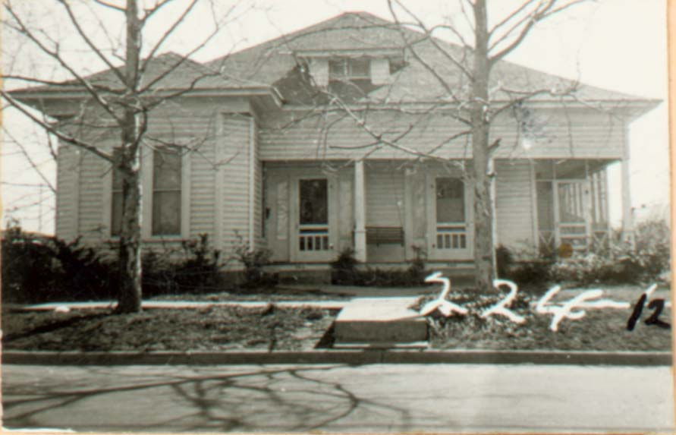
702 Bell Avenue, Home of Dr. Edwin Moten in Quakertown
Photo provided by the African American Museum of Denton, TX

Figure 2
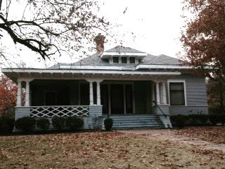
701 W. Oak Street, Denton, Texas
Photo by Lucy Bartholomee

Figure 3
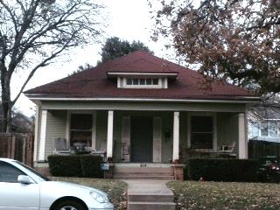
416 Hickory Street, Denton, Texas
Photo by Lucy Bartholomee

Figure 4
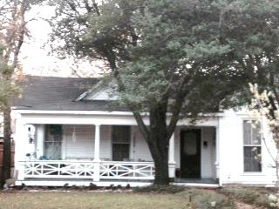
607 W. Oak Street, Denton, Texas
Photo by Lucy Bartholomee

Figure 5
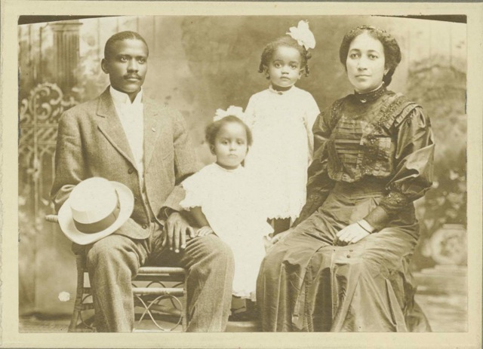
Dr. Moten and his family, Myrtle Bell Moten, Carrie Annetta Moten, and Susie Whitlock Moten.
Source: (http://texashistory.unt.edu/ark:/67531/metapth14900/ : accessed December 08, 2014), University of North Texas Libraries, The Portal to Texas History, http://texashistory.unt.edu; crediting Courthouse-on-the-Square, Denton, Texas.

Figure 6
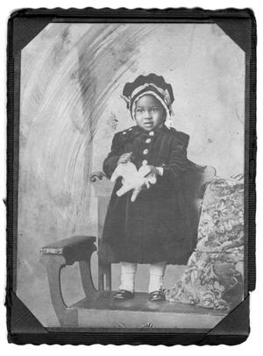
Portrait of Carrie Annetta Moten, wearing what appears to be a velvet dress and matching cap, with boots, and holding a toy, circa 1910
Source: (http://texashistory.unt.edu/ark:/67531/metapth14926/ : accessed December 08, 2014), University of North Texas Libraries, The Portal to Texas History, http://texashistory.unt.edu; crediting Courthouse-on-the-Square.
Figure 7
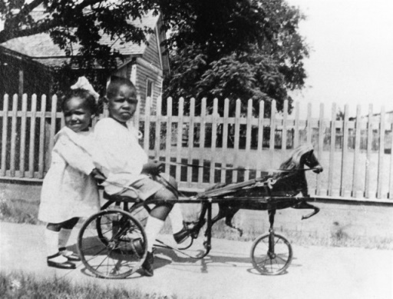
Dr. Moten’s son and daughter, 1923
Source: (http://texashistory.unt.edu/ark:/67531/metapth388165/ : accessed December 08, 2014), University of North Texas Libraries, The Portal to Texas History, http://texashistory.unt.edu; crediting UNTOHP, [No City Listed], Texas.

Figure 8
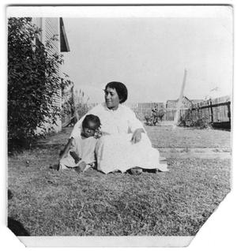
Susie Whitlock Moten with her son, E. D. Moten, Jr., circa 1916
Source: (http://texashistory.unt.edu/ark:/67531/metapth14915/ : accessed December 08, 2014), University of North Texas Libraries, The Portal to Texas History, http://texashistory.unt.edu; crediting Courthouse-on-the-Square, Denton, Texas.

Figure 9

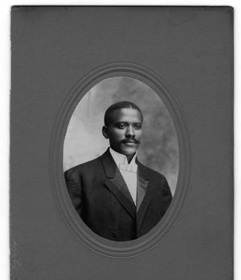
Dr. E. D. Moten, 1907
Source: (http://texashistory.unt.edu/ark:/67531/metapth14899/ : accessed December 08, 2014), University of North Texas Libraries, The Portal to Texas History, http://texashistory.unt.edu; crediting Courthouse-on-the-Square, Denton, Texas.
Figure 10

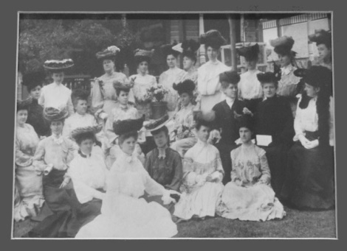
Ariel Club, Photograph, 1904

Source: (http://texashistory.unt.edu/ark:/67531/metapth16130/ : accessed December 09, 2014), University of North Texas Libraries, The Portal to Texas History, http://texashistory.unt.edu; crediting Denton Public Library, Denton, Texas.

Figure 11
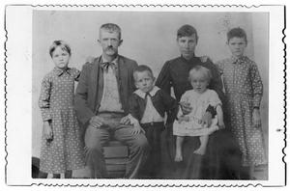
Unknown Family Portrait, circa. 1900
Source: (http://texashistory.unt.edu/ark:/67531/metapth12395/ : accessed December 09, 2014), University of North Texas Libraries, The Portal to Texas History, http://texashistory.unt.edu; crediting Denton Public Library, Denton, Texas.

Figure 12
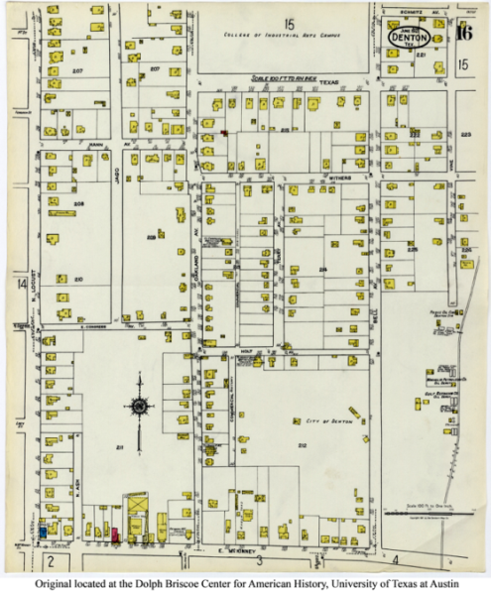
Sanborn map of the Quakertown area of Denton, Texas from June 1921; red arrow added by the author to indicate the location of Dr. Moten’s home at 702 Bell Avenue.
Retrieved from: http://www.lib.utexas.edu/maps/sanborn/d-f/txu-sanborn-denton-1921-16.jpg on December 10, 2014

W.E.B. Du Bois, The Souls of Black Folk (United States: Dover Publications, 2004), 2.
Douglas K. Boyd, Kim McCoig Cupit, and Nina Thurman. “The Quakertown Well: Historical Archeology of a Displaced African American Community in Denton, Texas,” Current Archeology in Texas 7, no 2. (November 2005): 1.
Ibid.
Ibid.
Ibid.
Laura Douglas, Quakertown. Denton County Historical Commission. Accessed on December 8, 2014. http://apps.dentoncounty.com/website/historicalmarkers/historical-markers.htm#Quakertown: 1.
Ibid., 2-3.
Ibid., 4.
Michele Powers Glaze, “The Quakertown Story.” The Denton Review: A Journal of Local History 3, no. 1 (1991): 8.
Ibid.
Ibid., 7
Ibid., 14.
Ibid.
Grace Elizabeth Hale. Making Whiteness: The culture of Segregation in the South, 1890-1940. (U.S.A.: Random House LLC, 2010), 6.
Chris Tilley, et al, Handbook of material culture (Great Britain: Sage, 2006), 1.
W.E.B. Du Bois, The Souls of Black Folk, 1.
Franz Fanon, Black Skin, White Masks (New York, NY: Grove Press, 2008), 95.
Ibid., 95.
Laura Douglas, Quakertown, 10.
Kim Cupit, (presentation, African American Museum, Denton, TX, September 24, 2014.)
Ibid.
Ibid.
Michele Powers Glaze. “The Quakertown Story,” 14-15.
Ibid., 7-8.
Michele Powers Glaze. “The Quakertown Story,” 26-27.
Sara Ahmed. Queer Phenomenology (London, England: Duke University Press, 2006), 148.
Ibid.
Virginia McAlester, and Arcie Lee McAlester. A Field Guide to American Houses (United States: Knopf, 1984), 397.
Ibid., 236.
Ibid., 404 and 417.
Ibid., 346-7.
W.E.B Du Bois. The Souls of Black Folk, 85.
Ahmed, Sara. Queer Phenomenology, 128.
Ahmed, Sara. Queer Phenomenology, 137.
Ahmed, Sara. Queer Phenomenology, 131.
bell hooks [sic], "An Aesthetic of Blackness: Strange and Oppositional." Lenox Avenue: A Journal of Interartistic Inquiry, 1995: 65-72.
Franz Fanon, Black Skin, White Masks, 119.
Michele Powers Glaze, “The Quakertown Story,” 15.
Franz Fanon, Black Skin, White Masks, 118.
Sara Ahmed, Queer Phenomenology, 131.
Ibid., 136.
Michele Powers Glaze. “The Quakertown Story,” 13.
Kurt Vonnegut, Armageddon in Retrospect (New York, NY: Random House, 2008), 25.

